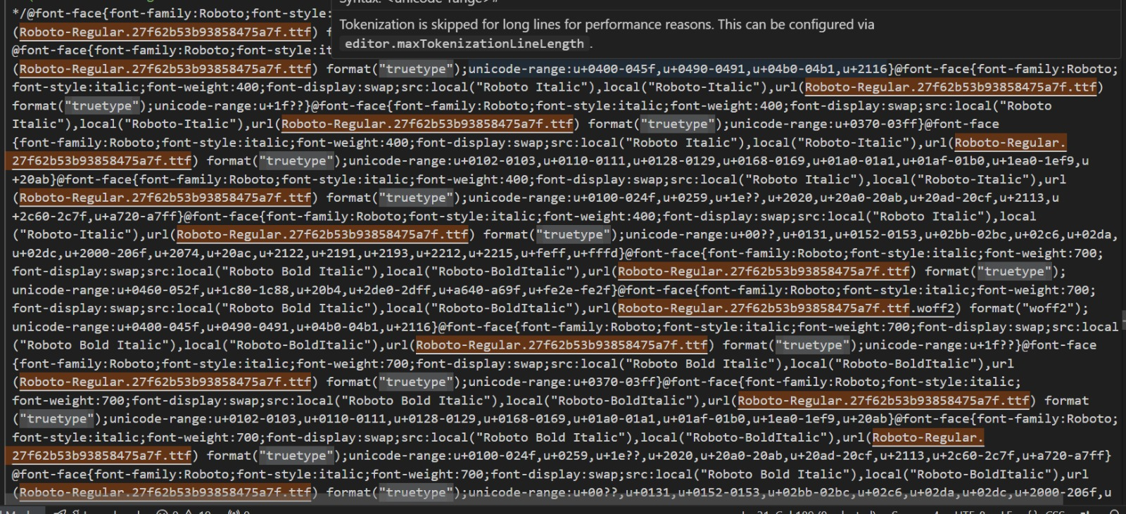

**1**. Change index.html like as <base href="/esignature/">

**2**. Remove Version number by checking light house Best Performance>Best practice>version.

**3**. Change styles.56d769321b7c695e14f2.css file like below /demo pic

Roboto-Regular.27f62b53b93858475a7f.ttf

-change url instead of exists

truetype

-change format instead of exists